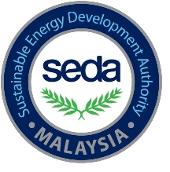


APPLICATION FORM
SAVE REBATE PROGRAM FOR CHILLER
Please either type directly in this form using Microsoft Word in BLOCK CAPITALS.
for office USE ONLY

Date Received: | Rebate Amount:

Date of accreditation by SEDA Malaysia:

1. company details

Company name

Installation address
Postcode: | State:

Mailing address (if different to installation address above)
Postcode: | State:
2. Applicant’s details

Title | Name of owner/Contact person

Position in company

Contact details
Office: | Fax: | Mobile:
Email address:

3. account information

Name of bank
Bank account holder name
Bank account no.

OR Name of cheque issuance

4. declaration and signature

I hereby certify that I have read, understood and met all eligibility requirements in the guidelines and have provided true and correct information in this application.

Applicant Signature Date
Return application and attachment to:
SAVE Rebate Program (Chiller), Energy Efficiency,
Sustainable Energy Development Authority Malaysia (SEDA Malaysia)
Galeria PjH, Level 9, Jalan P4W, Persiaran Perdana, Presint 4, 62100 Putrajaya.
(u.p: Mr. Mohd Amirshaifulrazain Bin Abu Zaini)

Tel: 03-8870 5856 | Fax: 03-8870 5900 | e-mail: amir@seda.gov.my
For more details please log on www.saveenergy.gov.my

